

Department of Computing

CS 250: Data Structures and Algorithms

Class: BSCS – 6C

Lab 7: Implementation of Stack ADT

Date: 3rd November 2017

Time: 10am-1pm

Instructor: Mr. Abid Rauf

CS250: Data Structure and Algorithms Page 1

Lab 7: Implementation of Stack ADT

Introduction

This lab consists of stacks implementation and some of its applications.

Objectives

The objective of this lab is to enable students to build stack ADT using arrays and implement balanced braces application.

Tools/Software Requirement

Visual Studio C++

Description

A stack is meant to mimic the information storage and retrieval in LIFO (Last In First Out) order.
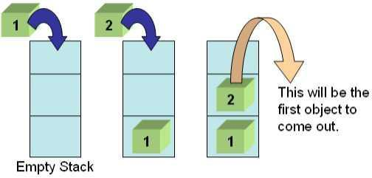

Lab Tasks

Task 1:
Stack Operations

- void Push(element) – pushes an element on top of stack

- element Pop() – removes and displays the element on top of stack

- bool isEmpty() – checks if the stack is empty or not

- bool isFull() – checks if the stack is full or not

- void Peek() – displays the contents of top element of stack

CS250: Data Structure and Algorithms Page 2

Task 2

The idea is rather simple: You keep a Stack of braces, and every time you encounter an open brace, you push it into your stack. Every time you encounter a closing brace, you pop the top element from your stack. At the end, you check your stack for being empty. If so, indeed your input string contained balanced braces. Otherwise, it didn't.

Expected Input

- 1 + 2 * (3 / 4)
- 1 + 2 * [3 * 3 + {4 – 5 (6 (7/8/9) + 10) – 11 + (12*8)] + 14
- 1 + 2 * [3 * 3 + {4 – 5 (6 (7/8/9) + 10)} – 11 + (12*8) / {13 +13}] + 14

Your program will determine whether the open brackets (the square brackets, curly braces and the parentheses) are closed in the correct order.

Expected Output of the above 3 inputs would be

- This expression is correct.
- This expression is NOT correct. Error at character # 10. ‘{‘- not closed.
- This expression is correct.

Solve the above problem using an array based stack.

Task 3:

Evaluate the correct expression in Task 2 using stack data structure.

Deliverables

Students are required to upload the lab on LMS before the deadline. The name of your document should be YourFullName_reg#.doc

Remember to comment your code properly.

CS250: Data Structure and Algorithms Page 3

